# Ansible : Configuation Management tool.

Ansible is a Configuration Management tool.

The client IP's are configured in Hosts file (Inventory) in Server.

Playbooks are the configurations written in YAML. PLAYBOOKS is a technical term used.

The Core of Ansible is it's Playbook.

Playbooks are the instructions to configure the nodes.

* Ansible is a Agent-less tool which means no need to install any supporting software or plugins to the nodes or the client systems.
* Only Ansible is installed in the local machine or the Server.
* Ansible has the Automated reporting which gives the report of Successful, failed or unreachable status.

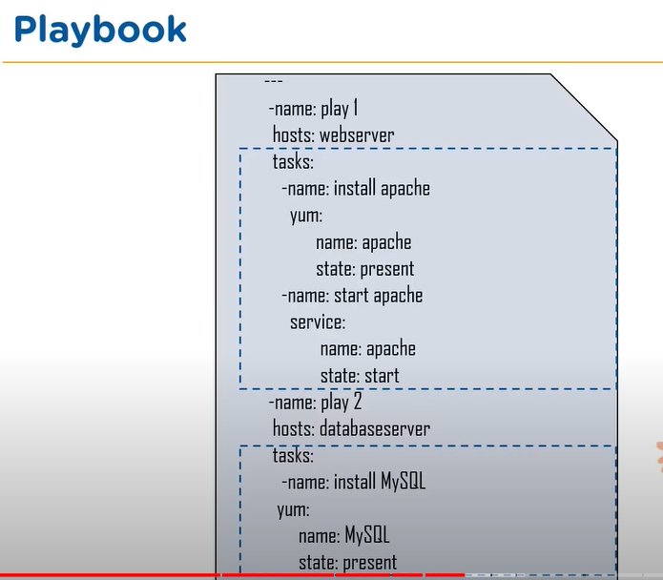

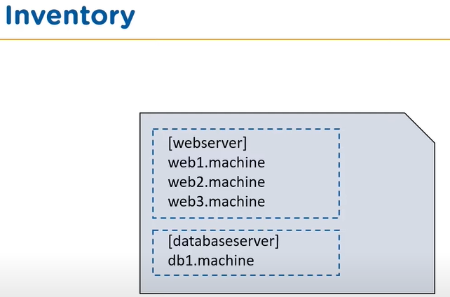

YAML file is used for configuring the systems

* Similar DevOps tools to ANSIBLE are CHEF and PUPPET

Command to check the Syntax of the YAML file:

* ansible-playbook sample.yml --syntax-check

If the syntax is correct, the output will be the playbook name which is sample.yml here.

Command to push the playbook on to the client nodes.

* ansible-playbook sample.yml

There are two types of Configurations with respect to Ansible server and client nodes.

* PULL Configuration : Nodes check with the server periodically and fetch the configurations from it.
* PUSH Configuration : Server pushes configuration to the nodes

Unlike CHEF and PUPPET, Ansible is push type Configuration Management Tool.

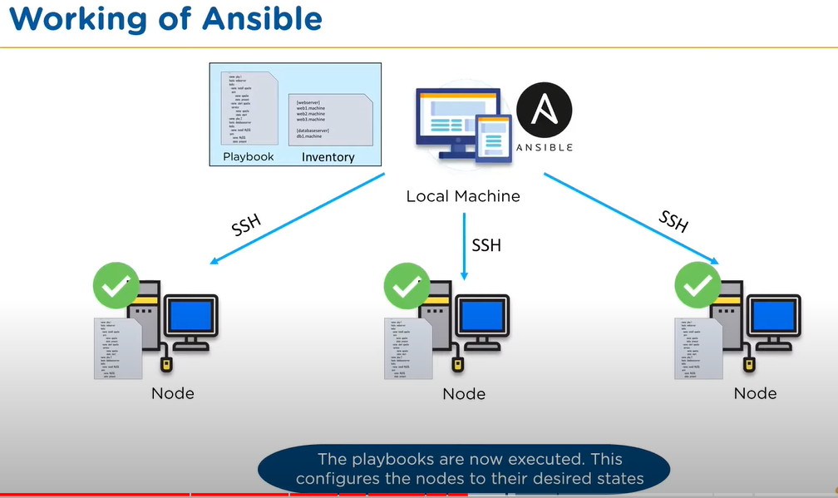

Architecture of Ansible :

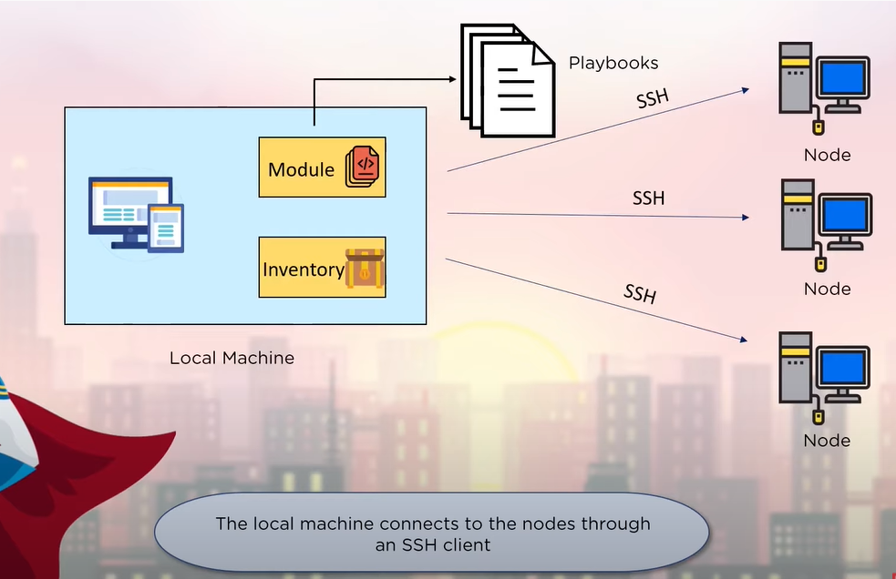

Ansible Tower by RED HAT:

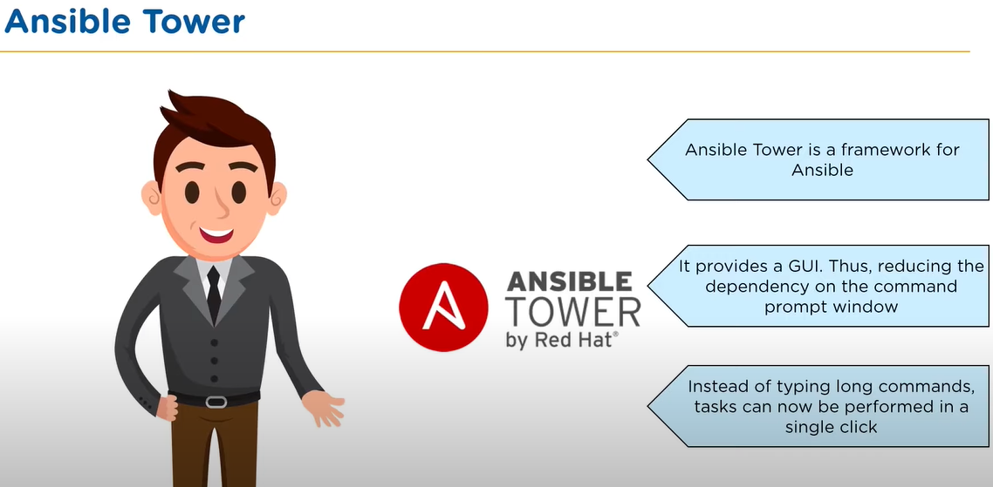

Installation of Ansible :

1. Below is for installing in CentOS:

Command : **yum install ansible -y**

1. Configuring the Inventory OR host file.

C:\Users\akumar6\AppData\Local\Microsoft\Windows\INetCache\Content.MSO\B44B6140.tmp

Path to the hosts file.

**# vi /etc/ansible/hosts**

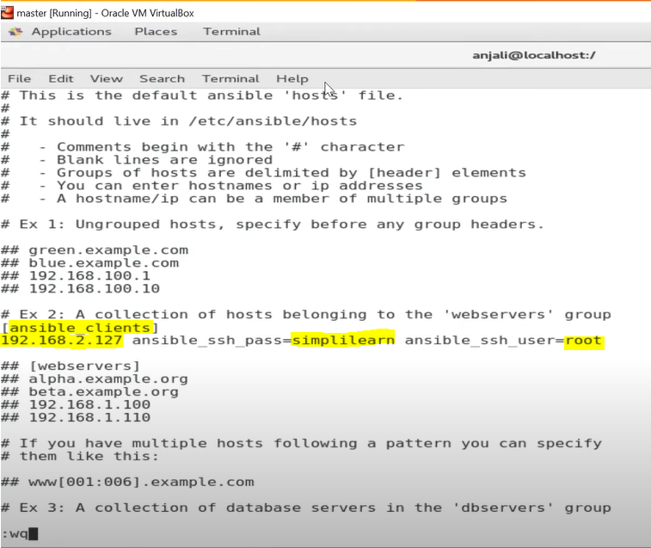

1. **Writing the playbook (instructions to perform in the client / node machines)**

**# vi sample.yml**

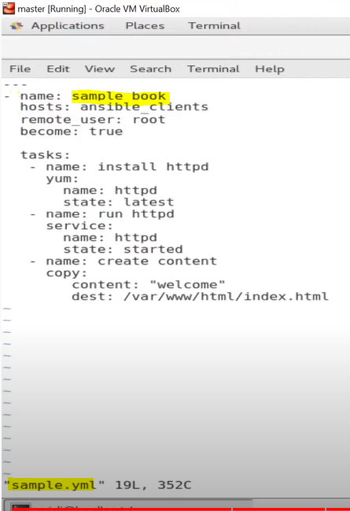

1. **Checking Syntax of YAML file.**

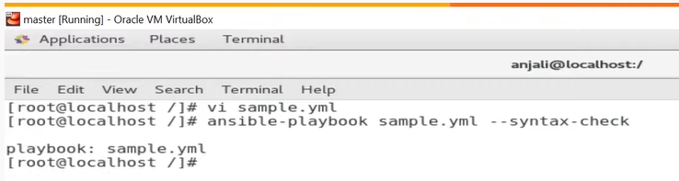

1. **Command to Execute the Playbook.**

